GenAI-Powered Content Compliance Generator
Assignee: Ankush
Assigned By: Maziya Iffat
Assigned On: 12th January 2026
Abstract
Digital media organizations generate massive volumes of content daily across news, social platforms, advertising, and user-generated channels. A significant portion of content unknowingly violates platform policies, legal regulations, or ethical guidelines, leading to content takedowns, monetization loss, reputational damage, and regulatory penalties.
This project proposes a GenAI-Powered Content Compliance Generator that automatically creates, rewrites, or validates media content to ensure compliance with editorial standards, platform rules, and legal regulations. The system uses Generative AI, Prompt Engineering, and Policy-Aware Retrieval-Augmented Generation (RAG) to ground content generation strictly within approved policy boundaries.
The solution shifts compliance from a manual, post-hoc review process to a proactive, AI-driven content creation pipeline.
Problem Statement

Current Challenges in Media Content Compliance
- Creators are unaware of complex policy rules
- Manual moderation is:
  - Slow
  - Expensive
  - Inconsistent
- Policies change frequently (platform + legal)
- Generative models may hallucinate or overstep
- Compliance checks happen after publishing, not before

Project Objectives
- Generate policy-compliant media content
- Embed platform + legal policies directly into generation
- Reduce content takedowns and rework
- Provide transparent compliance reasoning
- Support multi-policy, multi-platform environments
- Enable real-time compliant content creation

Domain Focus: Media

Types of Media Content Covered
Content Type | Risk Examples
News Articles | Defamation, misinformation
Social Media Posts | Hate speech, misinformation
Advertisements | False claims, restricted products
Video Scripts | Copyright violations
Headlines | Clickbait / misleading claims

Use-Case Scenarios

Scenario 1: Newsroom Content Creation
- Journalist writes breaking news
- GenAI rewrites it:
  - Removes speculative language
  - Ensures legal neutrality
- Outputs publish-ready compliant content

Scenario 2: Social Media Team
Prompt:
“Generate a promotional post for a political documentary.”
System Action:
- Retrieves:
  - Platform political content rules
  - Election-period regulations
- Generates neutral, compliant post

Scenario 3: Policy Update Handling
- Platform updates hate-speech guidelines
- Policy RAG auto-indexes new rules
- All future content reflects updated policy instantly
Project Description
The GenAI-Powered Content Compliance Generator is a policy-first generative system.
Instead of:
“Generate content → check compliance later”
It enforces:
“Retrieve policies → constrain generation → explain compliance”

Key Capabilities:
- Policy-grounded generation
- Automatic rewriting for compliance
- Transparent policy citation
- Multi-platform adaptability

Technical Architecture
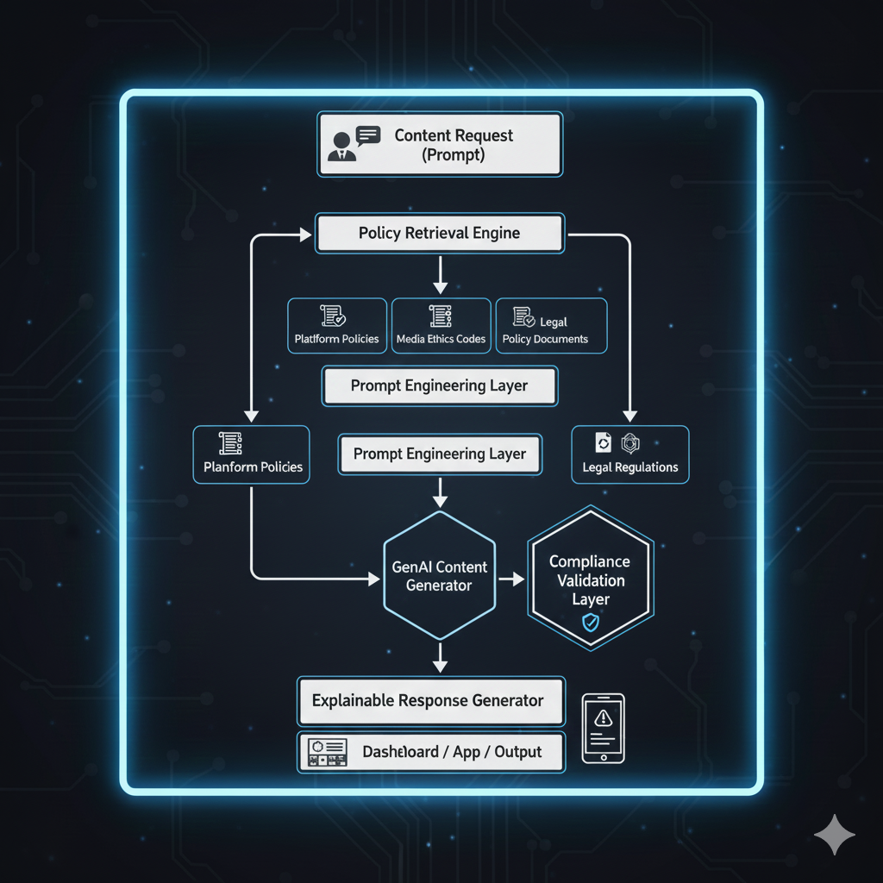

Tech Stack

🔹 Core Technologies
Layer | Technology
Language | Python
GenAI Model | GPT / LLaMA / Gemini
RAG Framework | LangChain
Vector DB | FAISS / Chroma
Prompt Engineering | Structured & Rule-aware prompts
Backend | FastAPI
Database | PostgreSQL
Frontend | Streamlit
Security | Role-based access

Step-by-Step Implementation

Step 1: Policy Data Collection

Platform rules (social media, ads)

Media ethics guidelines

Legal content regulations

Internal editorial standards

Step 2: Policy Preprocessing

Convert policies to text

Chunk into rule-level segments

Tag with metadata:

Platform

Content type

Risk category

Step 3: Vectorization & Storage

Generate embeddings for policies

Store in Vector DB

Enable semantic retrieval

Step 4: Prompt Engineering

Create policy-aware prompts:

“Generate content strictly following retrieved rules”

Add refusal + safe-completion logic

Step 5: Policy-Aware RAG Pipeline

User prompt → retrieve policies

Inject policy context into LLM

Generate constrained content

Step 6: Compliance Validation Layer

Cross-check generated content

Flag policy risks

Auto-rewrite if needed

Step 7: Explainability Module

Attach:

Applied policy rules

Justification summary

Human-readable explanation

Step 8: Dashboard & Publishing

Content preview

Compliance confidence score

Audit log for regulators

Final Deliverables

Policy-Aware GenAI Content Generator

Multi-platform compliance engine

Explainable content justification

Policy-update auto-sync module

Media-ready dashboard

File Submission Format

Project Document

Demo Video
Duration: 5–7 minutes
Must Include:
- Problem overview
- Dataset explanation
- Workflow
- Prediction demo
- Visualization walkthrough

GitHub Repository

Drive Folder
Folder Name:
[Project Name] – Final Submission
Contains:
- Project Report (PDF)
- Demo Video
- Dataset
- GitHub repository link

Submission Date:
19th January 2026

